CFIHOS – Implementation Guide for Contractor 承包方实施指南

Acknowledgements 致谢
In 2012, Shell approached Netherlands-based process industry organization USPI to explore turning their corporate information standard into an industry-wide standard. The result was the CFIHOS (Capital Facilities Information Handover Specification) project.
壳牌于2012年与总部位于荷兰的流程工业组织USPI（荷兰流程工业协会）接洽，希望将其企业信息标准转化为行业标准，因而形成了CFIHOS（资产密集型设施信息移交规范）项目。
Its aim is to offer practical, standardized specifications for information handover that work across the supply chain – operators, contractors and suppliers. The most recent CFIHOS industry standard (Version 1.4) was published in October 2019 by USPI with support from the Engineering Advancement Association of Japan (ENAA). This document, describing the scope and procedures of CFIHOS, is part of this standard.
CFIHOS项目旨在为信息移交提供实用标准化规范，该规范适用于整个供应链——运行方、承包方和供应方。CFIHOS 1.4版是由USPI在ENAA（日本工程协会）支持下发布的最新版，于2019年10月发布。本文件描述CFIHOS的承包方实施指南，是该标准的一部分。
Following a member vote in 2019, the future governance, development, and maintenance of the CFIHOS project and standard moved from USPI to IOGP in January 2020, becoming Joint Industry Project (JIP) 36.
2019年经成员投票表决，CFIHOS项目和标准的未来治理、编制和维护于2020年1月从USPI移至IOGP（国际油气生产方协会），成为JIP36（第36号联合工业项目）。
Disclaimer 免责声明
Whilst every effort has been made to ensure the accuracy of the information contained in this publication, neither IOGP nor any of its Members past present or future warrants its accuracy or will, regardless of its or their negligence, assume liability for any foreseeable or unforeseeable use made thereof, which liability is hereby excluded. Consequently, such use is at the recipient’s own risk on the basis that any use by the recipient constitutes agreement to the terms of this disclaimer. The recipient is obliged to inform any subsequent recipient of such terms.
尽管已尽一切努力确保本出版物中所含信息的准确性，但IOGP及其任何成员过去现在或未来均不保证其准确性，或无论其疏忽，均不对任何可预见或不可预见的使用承担责任，特此排除这些责任。受方的任何使用均构成对本免责声明条款的同意，因此此类使用的风险由受方自行承担。受方有义务将此类条款通知任何后续受方。
This publication is made available for information purposes and solely for the private use of the user. IOGP will not directly or indirectly endorse, approve or accredit the content of any course, event or otherwise where this publication will be reproduced.
本出版物仅供参考，仅供用户自用。IOGP不会直接或间接认可、批准或授权将复制本出版物的任何课程、活动或其他。
Copyright notice 版权声明
The contents of these pages are © International Association of Oil & Gas Producers. Permission is given to reproduce this report in whole or in part provided (i) that the copyright of IOGP and (ii) the sources are acknowledged. All other rights are reserved. Any other use requires the prior written permission of IOGP.
各页内容版权由IOGP所有（© International Association of Oil & Gas Producers）。在 (i) IOGP的版权和 (ii) 来源得到承认的前提下允许全部或部分复制本报告。IOGP保留所有其他权利。任何其他用途都需要IOGP事先书面许可。
These Terms and Conditions shall be governed by and construed in accordance with the laws of England and Wales. Disputes arising here from shall be exclusively subject to the jurisdiction of the courts of England and Wales.
这些条款和条件应受英格兰和威尔士法律管辖并按其解释。由此产生的争议应仅受英格兰和威尔士法院的管辖。

CFIHOS – Implementation Guide for Contractor 承包方实施指南

Version 版本 | Date 日期 | Comments/History 备注/记录
1.4 | April 2020  2020年4月 | IOGP republication of CFIHOS document first published in October 2019.  IOGP对首次于2019年10月发布的CFIHOS文档的再版。
1.5 | October 2021  2021年10月 | Minor update to section 3 with hyperlinks to new CFIHOS website and removed individual document links  对第3章的次要更新，增加了指向CFIHOS新网站的超链接，并删除了单个文档的链接。
1.5.1 | 2022-11  2022年11月 | Minor text changes for bug fixes throughout the text of the document  在本文件的整个文本中更正错误的次要文本变更。

Foreword 前言
The Capital Facilities Information Handover Specification (CFIHOS) is an industry standard developed to improve how information is exchanged between the companies who own, operate, and construct equipment for the process and energy sectors. Starting with a common equipment naming taxonomy and supporting specifications, its goal is to become a common language for the exchange of information in these sectors.
CFIHOS（资产密集型设施信息移交规范）是一项为改进流程与能源行业拥有、运行和制造设备的公司之间如何交换技术信息而制定的行业标准。CFIHOS始于公用设备命名分类法和支持规范，目标是成为流程与能源行业信息交换的公用语言。
The initial focus is on information, both structured data and traditional document formats, which must be handed over when a project moves from its development to operations phase. Ultimately, the aim is for CFIHOS to become the de-facto standard for information exchange throughout the physical asset lifecycle, from vendor information through to decommissioning.
CFIHOS起初关注项目从开发阶段进入运行阶段时必须移交的信息（结构化数据和传统文档格式）。CFIHOS终极目标是成为从供方信息至退役的整个物理资产生命周期信息交换的事实标准。
The Reference Data Library or “RDL” lies at CFIHOS’ heart. This library gives a standard and unified naming convention for equipment, its attributes, disciplines, and documents. The CFIHOS RDL includes:
- A list of classes for Tag and Equipment (what the equipment does and what it is)
- A list of properties (attributes, measures, characteristics etc.)
- Lists of requirements by class (data and document requirements)
- Standard unique coding of data to facilitate digital design and other workflows
- A list of document types
- A list of disciplines.
RDL（参考数据类库）是CFIHOS的核心，为设备及其属性、专业和文档提供一个标准且统一的命名规范。CFIHOS RDL包括：
- 位号和设备的类列表（设备及其功能）
- 特性列表（属性、计量、特征等）
- 按类的要求列表（数据和文档要求）
- 数据的标准唯一编码，以备数字化设计和其他工作流程使用
- 文档类型列表
- 专业列表
At present, CFIHOS covers only the exchange of structured data and documents - not graphical, geometry, and model data. In the future, CFIHOS could be extended to include graphical and design tool and support spare parts procurement, inspection, test requirements, commissioning check sheets, Work Packaging, configuration management, and even drive payment.
CFIHOS目前仅涵盖结构化数据和文档的交换，不涵盖图形、几何和模型数据。CFIHOS未来可能扩展至包括图形和设计工具，并支持备件采购、检验、试验要求、调试检查表、工作包、配置管理，乃至推动支付。
CFIHOS is being developed collaboratively by project members as a practical standard to ensure the systematic and reliable exchange of information between all participants involved in the information supply chain, thereby reducing cycle times and costs. More than 70 organizations contributed to the development of CFIHOS Standard, which is supported by several leading software industry design tools.
CFIHOS由项目成员作为实用标准协作编制，以确保信息供应链中涉及的所有参与方之间系统及可靠的信息交换，从而缩短周期并降低成本。CFIHOS标准参编组织超过70个，并得到一些软件行业领先设计工具支持。

Contents 目次
Foreword 前言 5
1 Introduction 介绍 8
1.1 General 总则 8
1.2 Scope 范围 8
1.3 Target Audience 目标受众 8
1.4 CFIHOS Document Structure CFIHOS文档结构 9
1.5 Terms, Definitions, Acronyms, and Abbreviations 术语、定义、首字母缩略词和缩略语 10
1.6 Information Management Principles and Process in Projects 项目信息管理原则与流程 12
2 How to use the CFIHOS Standard on a Project 如何在项目上使用CFIHOS标准 13
2.1 Contractual “Information Requirements Package” 合同“信息要求包” 14
2.1.1 Contract IM SoW 合同IM SoW 15
2.1.2 Contract Information Specification 合同信息规范 15
2.1.3 Reference Data 参考数据 18
2.2 CFIHOS Implementation Steps by the Contractor 承包方实施CFIHOS的步骤 18
2.2.1 Review and Confirm Understanding of the Information Requirements Package 复核并确认对信息要求包的理解 19
2.2.2 Determine the Approach and Procedure for Changes to the Specification 确定规范变更方法与程序 21
2.2.3 Identify the Sources (Providers) of the Information 确定信息来源（提供方） 21
2.2.4 Ensure Project-wide Awareness of the Requirements for Information and Quality 确保项目范围内具备信息和质量要求意识 21
2.2.5 Implement Procedures & Tools for Information Collection, Validation, Consolidation and Handover 信息采集、确认、合并和移交的实施程序及工具 22
2.2.6 Collect, Validate, and Consolidate Information 采集、确认和合并信息 22
2.2.7 Perform Handover 执行移交 23
3 Where to retrieve CFIHOS Documents, Tools, and Templates 检索CFIHOS文档、工具和模板的地址 23
Annex A – Contract Information Requirements Package – Overview 附录A 合同信息要求包——概述 25
Table of Figures 图列表
Figure 1: CFIHOS Document Structure 图1 CFIHOS文档结构 10
Figure 2: How to use CFIHOS on a Project, Overview 图2 如何在项目上使用CFIHOS——概览 14
Figure 3: Contract Information Requirements Package 图3 合同信息要求包 15
Figure 4: CFIHOS Implementation Steps 图4 CFIHOS实施步骤 20

Introduction 介绍

General 总则
This document describes how to implement the Capital Facilities Information Hand-Over Specification (CFIHOS) from a Contractor perspective. This guide does not discuss the expected organizational Information Management (IM) maturity required for effective implementation of the Specification.
本文件描述如何从承包方角度实施CFIHOS（资产密集型设施信息移交规范）。本文件不讨论有效实施规范所需预期IM（信息管理）组织成熟度。

Scope 范围
This document covers the steps to be considered implementing the CFIHOS standard when received as part of a Contract Information Requirements Package up to and including the delivery of the information.
本文件涵盖CFIHOS标准实施要考虑的步骤，从收到其作为某合同信息要求包的一部分到（并包括）信息交付。
When using this document, it is recommended that the following should be referenced and understood together.
- CFIHOS Specification Document [C-SP-001]
- CFIHOS Implementation Guide for Principal [C-GD-001]
- CFIHOS Reference Data Library [C-ST-001]
- CFIHOS Data Model [C-DM-001]
- CFIHOS Contract Scenario Templates.
使用本文件时宜一并参考和了解以下：
- CFIHOS规范[C-SP-001]
- CFIHOS委托方实施指南[C-GD-001]
- CFIHOS参考数据类库[C-ST-001]
- CFIHOS数据模型[C-DM-001]
- CFIHOS合同场景模板
For further instructional material on how to read the CFIHOS Data Model, refer to the Data modelling Training Material [C-DM-901] on the CFIHOS SharePoint site.
如何解读CFIHOS数据模型的进一步指导资料见CFIHOS SharePoint站点上的数据建模培训材料[C-DM-901]。

Target Audience 目标受众
This document should be read by:
- Project Managers who are typically accountable for the delivery of project information to the asset
- Engineering Managers who typically own the information to be specified and handed over
- Project Information Managers and consultants who are typically responsible for specifying the information and implementing the handover process between the various stakeholders, based on the CFIHOS Specification and Reference Data Library
- Engineers on the project responsible for generating, obtaining and reviewing the information
- Personnel that configures IT systems needed to produce, validate or store the data and documents to be handed over.
以下人员宜阅读本文件：
- 通常负责交付项目信息至资产的项目经理；
- 通常拥有规定和移交的信息的工程经理；
- 通常负责基于CFIHOS规范和参考数据类库规定信息，并实施不同利益相关方之间移交流程的项目信息经理和顾问；
- 负责生成、获得和复核信息的项目工程师；
- 配置生成、确认或存储要移交的数据和文档所需IT系统的人员。

CFIHOS Document Structure CFIHOS文档结构
The documents which form part of and support the CFIHOS standard are organized as shown in Figure 1. This guide, Implementation Guide for Contractor, is indicated in the red circle.
构成及支持CFIHOS标准的文档的组织结构见图1，其中红圈指明本文件。
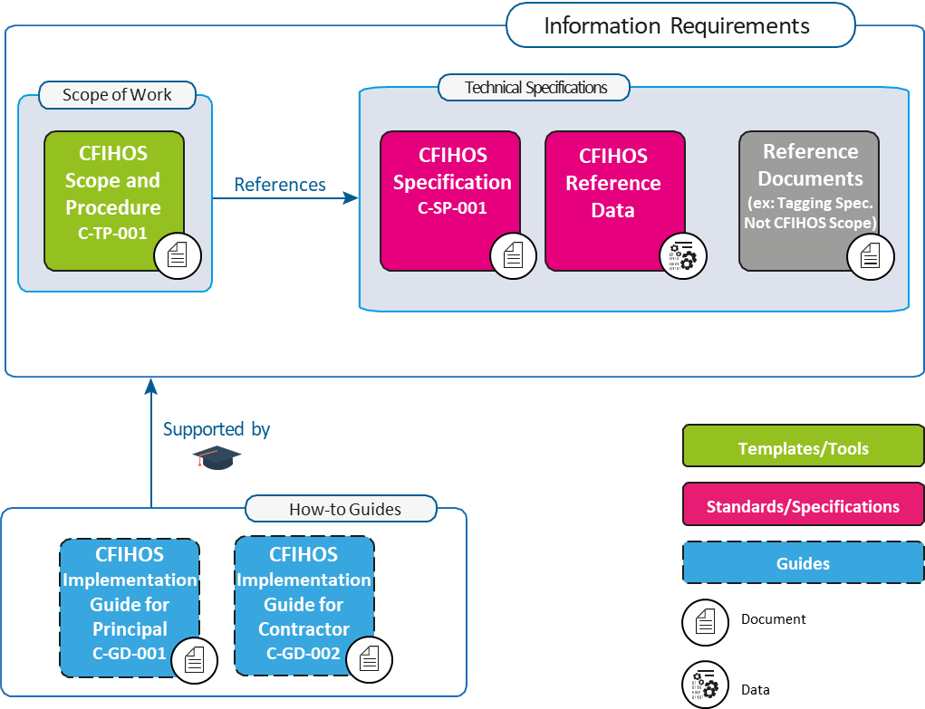
Figure 1: CFIHOS Document Structure
图1 CFIHOS文档结构
It is recognized that Principals may have different ways of organizing their contract documents for Capital Projects. For example, some Principals might include detailed descriptions of requirements within a Scope of Work, whereas other Scopes of Work might be a high-level description, with detailed requirements described in separate Specifications and Administration or Coordination Procedures.
公认的是委托方可用不同方式组织资产密集型项目合同文档。例如，一些委托方可能在合同文档中包含对工作范围内要求的详细描述，而其他委托方对工作范围可能为概要描述，详细要求在单独的规范和管理或协调程序中描述。
Another difference is that some Principals collect all of their Information Requirements into a single Information Management Scope of Work, whereas others define Information Requirements alongside other requirements for different parts of the Scope of Work. However, the Principal chooses to organize its Information Requirements, the following must be included in order to benefit from the CFIHOS standard:
1. “What” information is to be provided.
2. “How” the information is to be provided, including the format (document or data, file type) and how it is to be identified (document type, metadata, data identifier [CFIHOS Unique ID]).
3. “When” the information is to be provided. This is outside the scope of the CFIHOS Specification [C-SP-001]. However, the CFIHOS Scope and Procedure [C-TP-001] provides some basic information on this topic.
4. The quality measures used to understand the completeness, timeliness, and accuracy of the information. This is not currently addressed by the CFIHOS standard, however, the CFIHOS Scope and Procedure [C-TP-001] provides some basic information on this topic.
另一个区别是，一些委托方在单一信息管理工作范围中汇集所有信息要求，而其他委托方则将信息要求与对工作范围不同部分的其他要求一同定义。为受益于CFIHOS标准，无论委托方如何选择组织信息要求，信息要求必须包括以下：
- 提供“什么”信息；
- “如何”提供信息，包括格式（文档或数据、文件类型）以及如何识别信息（文档类型、元数据、数据标识符[CFIHOS唯一标识符]）；
- “何时”提供信息。此主题不在CFIHOS规范[C-SP-001]范围内，但CFIHOS范围与程序[C-TP-001]提供一些相关基础信息；
- 用于解释信息完整性、及时性和准确性的质量措施。CFIHOS标准目前未涉及该主题，但CFIHOS范围与程序[C-TP-001]提供一些相关基础信息。

Terms, Definitions, Acronyms, and Abbreviations 术语、定义、首字母缩略词和缩略语
A complete definition of terms is available in the CFIHOS Specification Document [C-SP-001]. A few key terms used in this document are included below.
CFIHOS规范[C-SP-001]提供完整术语定义。本文件使用的一些关键术语包括以下。
Contract Information Management Scope of Work (IM SoW): In this contractual document the Principal specifies the terms and conditions for information delivery by the Contractor. Where it is applicable and feasible, quality benchmarks and criteria to fulfil may be included. For any details, there could either be reference to a specific specification document or included in the scope of work. CFIHOS Scope and Procedure document [C-TP-001] is used as a reference to create the project or contract specific Information Management Scope of Work. The term Project Information Management Scope of Work can also be used.
IM SoW（合同信息管理工作范围）：委托方在此合同文档中规定承包方交付信息的条款和条件，可在适用且可行的情况下包括满足这些要求的质量基准和准则。细节可以引用特定规范或包含在工作范围内。CFIHOS范围与程序[C-TP-001]用作创建项目或合同特定信息管理工作范围的参考。也能使用术语“项目信息管理工作范围”。
Contract Information Specification (CIS): The resulting document when this industry guideline is applied to a particular project describing the specific set of requirements to be fulfilled. Linked to this document is a Reference Data Library that describes the data characteristics and document types.
The CFIHOS Specification Document [C-SP-001] is the basis for creating a project or contract specific Information Specification.
CIS（合同信息规范）：将CFIHOS标准应用于特定项目时生成的文档，描述要满足的特定要求集。描述数据特征和文档类型的参考数据类库链接至该文档。
CFIHOS规范[C-SP-001]是创建项目或合同特定信息规范的基准。
Discipline Document Type: An association between Disciplines and Document Class names. In the CFIHOS context, the term Discipline Document Type is a unique identifier for types of documents, which allows deliverables to be specified and content ownership to be assigned by discipline. This term has been developed to cater for situations where a document class is common to more than one discipline, for example, a Data Sheet, which could be produced by different disciplines depending on the nature of the associated equipment.
专业文档类型：专业和文档类名之间的一种关联。术语“专业文档类型”在CFIHOS中是文档类型的唯一标识符，以容许按专业规定交付物并指派内容所有权。该术语为满足一个以上专业公用一个文档类的情况而制定，例如数据表可能由不同专业根据相关设备性质生成。
Contractor (Or EPC Contractor): The party that carries out all or part of the design, engineering, procurement, construction, commissioning or management of a project or operation of a facility. The Principal may undertake all or part of the duties of the Contractor.
承包方（或EPC承包方）：执行全部或部分项目设计、工程设计、采购、施工、调试或管理，或设施运行的一方。委托方可承担承包方的全部或部分职责。
Principal (or Owner/Operator): The party that initiates the project and ultimately pays for it. The Principal may also include an agent or consultant authorised to act for, and on behalf of, the Principal.
委托方（或业主/运行方）：发起项目并最终为其出资的一方。委托方还可包括被授权代表委托方并为其行事的某代理方或顾问方。
Reference Data Library (RDL): Reference Data Library of the metadata of Data and Documents described in CFIHOS Specification Document [C-SP-001]
RDL（参考数据类库）：CFIHOS规范[C-SP-001]所述数据和文档元数据的参考数据类库。
SEED file: File that contains set-up information that must be loaded for a software application to work properly. A seed file may contain class, type and attribute definitions, UOM, symbols, catalogues, assemblies, valid value lists, breakdown structures, report definitions, etc. The content of a seed file varies based on the standardization and application integration requirements of its provider.
种子文件：包含为使软件应用程序正常工作而必须加载的设置信息的文件。种子文件可包含类、类型和属性定义、UOM、符号、元件库、程序集、有效值列表、分解结构和报告定义等。种子文件内容根据其提供方的标准化和应用程序集成要求而有所不同。
Shall is used to dictate absolute requirements.
应用于指定绝对要求。
Should is used to describe recommendations where noncompliance can be acceptable.
宜用于描述推荐，在此情况下能接受不合规。

Information Management Principles and Process in Projects 项目信息管理原则与流程
For this implementation guide, a few key points are important:
- A Capital Project typically delivers two assets to the Principal organization; a physical asset and an information asset
- Principals are responsible for specifying the requirements for both the physical asset and the information asset
- EPCs, Suppliers/Manufacturers (Vendors) and other third parties are responsible for creating and delivering a high-quality information asset to the Principal, which in turn can be used for Operations, Maintenance and possible future Modifications
- The information asset will include both Documents (printed or electronic, for human interpretation) as well as Data (stored in a structured format and manipulated using software applications).
以下关键点对本文件是重要的：
- 资产密集型项目通常向委托方组织交付两项资产：物理资产和信息资产；
- 委托方负责规定对物理资产和信息资产的要求；
- EPC、供应方/制造方（供方）和其他第三方负责创建并向委托方交付高质量的信息资产。信息资产进而能用于运维和未来可能的改造；
- 信息资产包括文档（供人解读的纸质或电子文档）和数据（以结构化格式存储，并使用软件应用程序操作）。
From a Contractor perspective, the information management process involves the following main steps:
- Review and confirm understanding of the CFIHOS based information and compliance requirements for deployment in the project execution environment.
- Identify the sources (providers) of the information.
- Align the project execution environment in terms of organization, procedures and systems for information generation, collection, validation, and handover.
- Collect, validate, and consolidate the information to ensure the quality of the information deliverables is compliant with the requirements.
- Handover information deliverables to the Principal
- Correction of deliverable non-conformances and handling of changes in the requirements due to project developments
信息管理过程从承包方角度涉及以下主要步骤：
- 复核并确认对在项目执行环境中部署的，基于CFIHOS的信息和合规性要求的理解；
- 确定信息来源（提供方）；
- 在组织、程序和系统方面调整项目执行环境，供信息生成、采集、确认和移交；
- 采集、确认和合并信息，以确保信息交付物的质量遵守要求；
- 移交信息交付物给委托方；
- 纠正交付物不符合项，处理因项目进展而导致的要求变更。

How to use the CFIHOS Standard on a Project 如何在项目上使用CFIHOS标准
This chapter describes how the CFIHOS standard could be applied to a project.
本章描述如何在项目上应用CFIHOS标准。
The information exchange process starts with the review of the information requirements package, deciding how to meet the requirement and implementation by configuring and/or mapping internal information systems to comply with CFIHOS, and by specifying CFIHOS compliant deliverables in any sub-contracted work.
信息交换过程始于复核信息要求包，决定如何达到要求并实施（通过配置或映射内部信息系统以遵守CFIHOS，及在所有分包工作中规定CFIHOS合规交付物）。
In Figures 2 and 4 and the following sections, the implementation process for the Contractor is described in more detail.
对承包方实施过程的更详细描述见图2与图4及以下各条。
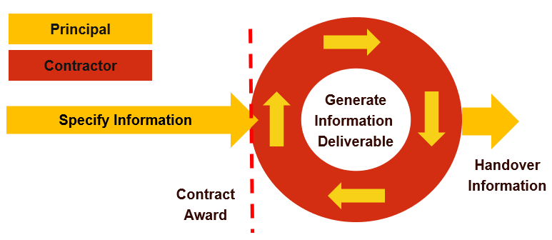
Figure 2: How to use CFIHOS on a Project, Overview
图2 如何在项目上使用CFIHOS——概览

Contractual “Information Requirements Package” 合同“信息要求包”
The Principal typically has a contracting and procurement process by which a ‘Prime Contract’ or another contractual vehicle is agreed with a Contractor to deliver a project scope. The Principal’s information requirements are included in this ‘Prime Contract’ or another contractual vehicle, as appropriate. Often, these information requirements are outlined in an “Information Requirements Package” consisting of the following documents created by the Principal (based on the CFIHOS Standard). See Figure 3 and section 1.5 for terms and definitions:
- Contract Information Management Scope of Work (IM SoW)
- Contract Information Specification (CIS), including:
  - Reference Data (CFIHOS RDL)
  - Reference Documents (Not in CFIHOS scope) most likely to be Principal specific.
委托方通常有一个发包和采购流程。委托方通过该流程与承包方商定主合同或其他合同载体，以交付项目范围。此“主合同”或其他合同载体视情包含委托方信息要求。由委托方创建的以下文档（基于CFIHOS标准）组成的“信息要求包”经常概述这些信息要求，术语和定义见图3和1.5。
- 合同IM SoW（信息管理工作范围）
- CIS（合同信息规范），包括：
  - 参考数据（CFIHOS RDL）
  - 参考文档（不在CFIHOS范围内），最可能是委托方特定的。
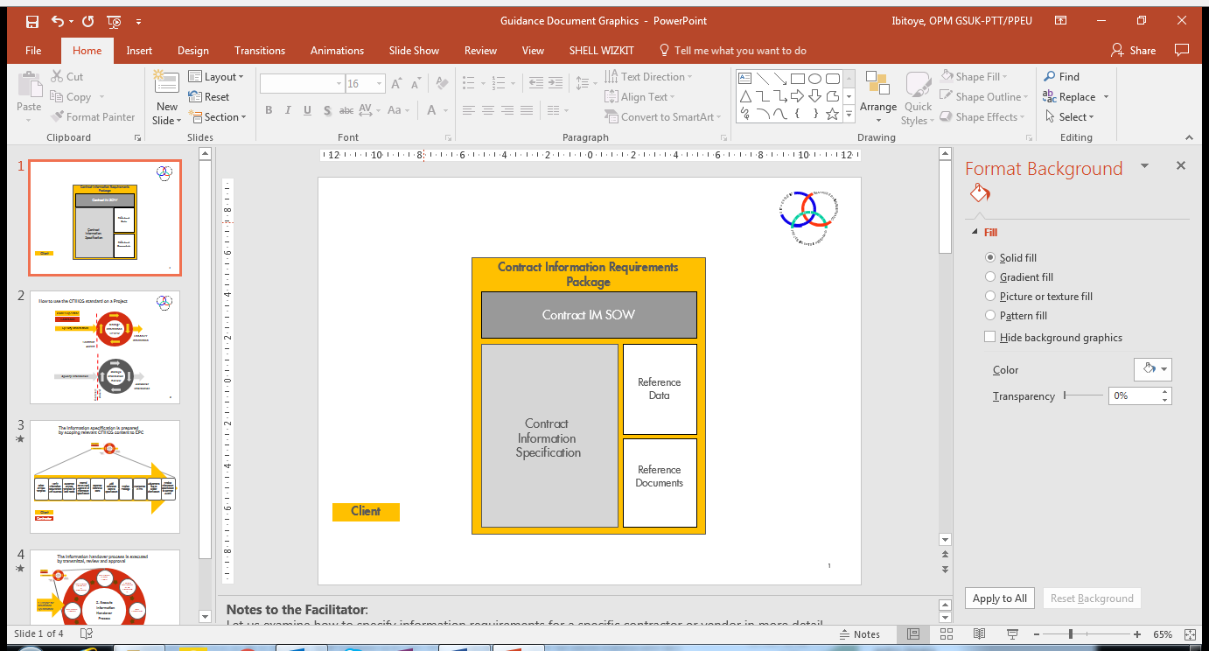
Figure 3: Contract Information Requirements Package
图3 合同信息要求包
Depending on the structure of each Principal’s Prime Contract, the contractual requirements covering information management and handover may not necessarily be centralized into a single Information Requirements Package and may be found dispersed throughout the Prime Contract.
根据每个委托方主合同的结构，涵盖信息管理和移交的合同要求可不必集中在单一信息要求包中，可分散在主合同中。
However, in this guide, the terms “Information Requirements” and “Information Requirements Package” have been used interchangeably as described above. The specification of the internal processes of the Contractor or the Principal is not part of the scope of this document.
但本文件如上所述互换使用术语“信息要求”和“信息要求包”。承包方或委托方内部流程规范不在本文件范围内。

Contract IM SoW 合同IM SoW
The goal of the Contract IM SoW document is to define certain aspects of the information requirements, i.e. the scope, processes, interdependencies and acceptance criteria for the exchange and handover of information between Contractor and Principal. It allows the Contractor to understand the expected deliverables, their timing and other success criteria, and it should enable the Principal to monitor the quality and progress of information creation and delivery in a progressive manner before the final handover.
合同IM SoW文档目标是定义信息要求的特定方面，即承包方与委托方之间的信息交换和移交范围、流程、互依关系和验收准则。这使承包方有可能领会委托方期望的交付物及其时间安排和其他成功准则，并宜使能委托方在最终移交前，以渐进方式监测信息创建及交付的质量和进度。
The IM SoW points to the Contract Information Specification which should identify what information is required to be delivered.
IM SoW指向合同信息规范，该规范宜确定要求交付的信息。

Contract Information Specification 合同信息规范
The goal of the Contract Information Specification is to define the technical aspects of the project information requirements; for which CFIHOS forms the basis. CFIHOS identifies a full generic super-set of information that may be produced in a project. In practice, the information specification will include a template that reflects the contract scenario applicable to the project.
合同信息规范目标是定义项目信息要求的技术方面，CFIHOS构成其基准。CFIHOS确定可在项目中生成信息的完整通用超集。信息规范在实践中将包括一个反映适用于该项目的合同场景的模板。
The template specifies what information a Principal delivers to a Contractor (e.g. naming conventions, classifications etc to be used) and what information the Principal expects to be delivered back by the Contractor (e.g. design data and equipment documentation). These scenarios/templates are:
该模板规定委托方向承包方提供的信息（例如要用的命名规范和分类等），以及委托方期望承包方交回的信息（例如设计数据和设备文档）。这些场景/模板为：
Template 1: EPC or ESC
模板1：EPC或ESC
Information requirements to be delivered for an Engineering, Procurement & Construction (EPC) Contract or Engineering Services Contract (ESC) contract scope.
EPC（设计、采购与施工）合同或ESC（工程服务承包方）合同范围内要交付的信息要求。
Template 2: FEED
模板2：FEED
Information requirements for a Front-End Engineering Design (FEED) Contract. In this Template, the procurement or delivery of any hardware, and associated information is considered to be out of scope.
FEED（前端工程设计）合同信息要求。所有硬件采购或交付以及相关信息不在此模板范围内。
Template 3: Document Only
模板3：仅文档
Information requirements for a Contract delivering documents only. This may include scenarios like Conceptual Engineering, Surveys/Studies and Site Preparation.
文档交付合同信息要求，可包括概念性工程、调查/研究和场地准备等场景。
Template 4: Package Vendor
模板4：成套设备供方
Information requirement for engineered equipment packages (i.e. skids, part of a plant), including how to code, format and exchange information (for review and handover) between Contractor and Principal. Typically, the scope is similar to an EPC Contract, but the volumes are smaller.
成套设备（即撬装设备、工厂的部分）信息要求，包括承包方与委托方之间信息编码、格式处理及交换（供复核和移交）方式。该范围通常类似于EPC合同，但信息量较小。
Template 5: Standard Equipment
模板5：标准设备
Information requirements for standard (off-the-shelf) equipment purchase orders, including how to code, format and exchange information (for review and handover) between Contractor and Principal.
标准（现货）设备订单的信息要求，包括承包方与委托方之间信息编码、格式处理及交换（供复核和移交）方式。
Template 6: Concept Design
模板6：概念设计
Information specification template containing the Information Requirements for a Concept Design Contract. In the Concept Design template, the procurement or delivery of any hardware and the associated information is considered to be out of scope.
包含概念设计合同信息要求的信息规范模板。所有硬件采购或交付以及相关信息不在概念设计模板范围内。
Additional project specific requirements
项目附加特定要求
The CFIHOS template requirements may be augmented with the following additional requirements:
- Information requirements not covered by CFIHOS: These may include corporate practices or scope not currently included in CFIHOS.
- Project Specific reference data/specifications: These include taxonomies, object coding and naming conventions that are specific to the project or asset which the Principal expects Contractor to use for labelling or classification purposes.
- Brownfield projects may decide to comply with the numbering and classification structure of the original asset.
CFIHOS模板要求可增加以下附加要求：
- CFIHOS未涵盖的信息要求：可包括目前未包含在CFIHOS中的企业实践或范围；
- 项目特定参考数据/规范：包括委托方期望承包方用于标识或分类目的的项目或资产特定分类法、对象编码和命名规范；
- 改建项目可决定遵守原始资产的编码和分类结构。
Local needs
当地需要
Local needs for Documents or Data may be driven by local regulations which are not part of CFIHOS such as:
  - The need for a specific number of paper copies and their sizes
  - The delivery of quality certificates in accordance with local (government) regulations
  - (Bi)-lingual information deliverables.
文档或数据的当地需要可由当地法规驱动，但不是CFIHOS一部分，如：
  - 需要特定数量和尺寸的纸质副本；
  - 按当地（政府）法规交付质量证书；
  - （双）语言信息交付物。
Validation procedures
确认程序
The Principal will have developed validation procedures that will be used to assess the progress and to review the quality of the information delivered by the Contractor.
委托方将制定用于评估进度并复核承包方交付信息质量的确认程序。

Reference Data 参考数据
The reference data library (RDL) is a standard and unified naming convention for equipment classification, its properties, disciplines and documents. It is a set of information requirement specifications for documents and tagged items.
RDL（参考数据类库）参考数据类库是设备分类、设备分类属性、专业和文档的标准及统一命名规范，是对文档和位号项的信息要求规范集。
The project RDL, based on the CFIHOS standard RDL [C-ST-001] is tailored to specify the reference data for the contract scope.
定制基于CFIHOS标准RDL[C-ST-001]的项目RDL以规定合同范围参考数据。
The Principal may have populated and made available to Contractor in a project engineering information repository/Engineering Data Warehouse with reference data that will be utilized to specify the project RDL and/or for publishing the quality checked information during the project. It can also ensure that any software templates to be furnished by the Principal for use by the Contractor is compliant with the RDL.
委托方可向项目工程信息储存库/工程数据仓库（将用于规定项目RDL或在项目期间发布经过了质量检查的信息）填充参考数据，并提供给承包方。这也能确保委托方配备的供承包方使用的任何软件模板遵守RDL。
The reference data is an attachment to the Contract Information Specification.
参考数据是合同信息规范的一个附件。

CFIHOS Implementation Steps by the Contractor 承包方实施CFIHOS的步骤
Upon receipt of the Information Requirements Package, the Contractor would typically engage a Project Information Management organization with adequate skills to coordinate and execute the following steps.
承包方通常会在收到信息要求包后建立具有足够技能的项目信息管理组织来协调和执行以下步骤。
Figure 4: CFIHOS Implementation Steps
图4 CFIHOS实施步骤

Review and Confirm Understanding of the Information Requirements Package 复核并确认对信息要求包的理解
The CFIHOS based Information Requirements Package, including additional project specific requirements, should be reviewed for unambiguous and consistent definition.
为使定义无二义性且一致，宜复核基于CFIHOS的信息要求包，包括项目附加特定要求。
This review should include the feasibility of the completeness and quality expectations for multiple or continuous deliveries during project execution as the quantity and the quality of the information will only gradually become available.
因为信息的数量和质量只会逐渐变得可用，该复核宜包括在项目执行期间多次或连续交付的完整性和质量期望的可行性。
In case the Principal provides templates (e.g. SEED files) for software applications and/or deliverables to be used by Contractor, the compatibility of these templates with the information requirements should be reviewed.
如果委托方提供承包方要使用的软件应用程序或交付物的模板（例如种子文件），则宜复核这些模板与信息要求的兼容性。
This review is conducted by subject matter experts from Project Information Management, Technical Disciplines and often requires close cooperation with the Principal to clarify unclear items or confirmation of Contractor’s interpretation.
此复核由来自项目信息管理与技术专业的主题专家进行，通常需要与委托方密切合作以澄清不明确项或确认承包方的解释。
A review typically consists of checking that:
- The information items requested are unambiguously defined and are well understood
- Any deviations from the CFIHOS standard have been identified
- The validation criteria are clearly defined to allow automated quality checks and reporting
- It is feasible to provide information and quality at the requested delivery milestones
- There are procedures defined to handle information changes between deliveries (adds, replacements, deletes, modifications)
- In case the handover of Contractor engineering tools part of the requirements there is a consistency requirement between these tools (configuration/seed files) and the CFIHOS handover specification
- Consistency of Principal provided templates for deliverables and/or engineering tools (if any) with the other parts of the Contract Information Requirements Package. This applies to classifications, properties, picklists, Units of Measurement, etc.
- Availability of a mapping between CFIHOS and specifications specific to the information delivery into plant operation & maintenance systems
- The extent to which Principal defined project numbering systems for assets and documents are consistent with the CFIHOS based Contract Information Specification
- The method, format, meta-data, and frequency of information hand-over are clearly defined.
复核通常包括检查以下：
- 要求的信息项定义无二义性并得到很好的理解；
- 已识别与CFIHOS标准的所有偏离；
- 使自动质量检查和报告有可能的确认标准有明确定义；
- 在要求的交付里程碑提供经过了质量检查的信息是可行的；
- 定义了交付之间的信息更改（添加、替换、删除、修改）处理程序；
- 如果移交要求包括移交承包方工程工具，则这些工具（配置/种子文件）与CFIHOS移交规范之间要求一致；
- 针对分类、特性、值列表、计量单位等，委托方提供的交付物和/或工程工具的模板（如有）与合同信息要求包的其他部分一致；
- CFIHOS与给工厂运维系统的特定信息交付规范之间的映射可用；
- 委托方为资产和文档定义项目编码体系的程度与基于CFIHOS的合同信息规范一致；
- 信息移交的方法、格式、元数据和频次定义明确。
Note: A significant contributor to the efficient management of information is a complete and consistent project numbering system for objects like tags/equipment and documents. It shall also be clear which objects (classes) are subject to tagging/numbering.
注：对位号/设备和文档等对象的完整且一致的项目编码体系有利于高效的信息管理，还应明确哪些对象（类）需要标识/编码。
In general, plant operation & maintenance requirements lead to tagging/numbering of more object classes compared to those relevant for Contractor’s traditional scope and work processes. The project numbering specification should be complete and cover these object classes.
工厂运维相对承包方传统范围与工作流程一般要标识/编码更多的对象类。项目编码规范宜完整涵盖这些对象类。

Determine the Approach and Procedure for Changes to the Specification 确定规范变更方法与程序
Information structures, naming conventions and reference data/documents should remain fixed for the whole life cycle. In practice however, changes to the specification will occur during project execution. These changes may be initiated by the Principal or may be needed by the Contractor or its suppliers. Typical examples are properties and property pick list values. A change management approach and implementation strategy should be agreed with the Principal.
信息结构、命名规范和参考数据/文档宜在整个生命周期保持不变，但项目执行实践中会变更规范。变更可由委托方发起，也可因承包方或其供应方需要。典型示例是特性和特性值列表值。变更管理方法和实施策略宜与委托方商定。

Identify the Sources (Providers) of the Information 确定信息来源（提供方）
These are parties, internal and external to Contractor. Typically, these are the EPC disciplines of the Contractor, (equipment) suppliers/manufacturers, sub-contractors and in some cases, content providers specialized in supplying information for the process industry.
信息来源指承包方内外部各方，通常是承包方EPC专业、（设备）供应方/制造方和分包方，某些情况下则是专门为流程工业提供信息的内容提供方。
It is good practice to manage this responsibility in a matrix that indicates which discipline and organization (internal and external) need to deliver what information and when.
良好实践是用一个矩阵管理此职责，该矩阵指明哪些专业和组织（内部和外部）需要以及何时交付什么信息。

Ensure Project-wide Awareness of the Requirements for Information and Quality 确保项目范围内具备信息和质量要求意识
It is important that the necessary milestones, controls and incentives are cascaded into the total supply-chain along with the CFIHOS based information specification. This is achieved by the creation of specifications, instructions and organizing clarification and induction sessions dedicated to the parties involved.
重要的是将必要的里程碑、控制和激励与基于CFIHOS的信息规范一起传达至整个供应链。这通过创建规范、指示以及组织专门针对涉及的各方的澄清和培训会议实现。
In this process, focal points could be assigned from these parties. These focal points will be accountable for the provision of the information. It is important that among other project priorities (e.g. order placement for equipment to meet the schedule) the information delivery requirements remain a high priority. Clear and repeated support from project management in this area is crucial.
参与方可以在此过程中指派负责提供信息的联络点。重要的是信息交付要求在项目优先级（例如按进度下设备订单）中始终为高优先级。项目管理部门在这方面的明确和持续支持至关重要。

Implement Procedures & Tools for Information Collection, Validation, Consolidation and Handover 信息采集、确认、合并和移交的实施程序及工具
Identify the capabilities of the (external) parties, procedures, and systems for providing and collecting and validating the information. For a first implementation of CFIHOS an important part of the work in this step is the mapping of the requirements to information (templates) contained in the systems used by Contractor and/or external parties and implementing modifications to meet as much as practical the CFIHOS specification.
确定（外部）各方、程序和系统提供、采集和确认信息的能力。对于首次实施CFIHOS，本步骤工作的一个重要部分是将要求映射至承包方和/或外部各方所用系统包含的信息（模板），并进行修改以尽量满足CFIHOS规范要求。
CFIHOS is targeted at the information required by a Principal to operate and maintain a plant or for any future design changes. Because of this, it does not necessarily cover all information required by Contractor to execute its EPC work processes.
CFIHOS针对的是委托方运维工厂或将来进行任何设计更改所需信息，因此不一定涵盖承包方执行其EPC工作流程所需所有信息。
Certain information from an equipment supplier/manufacturer (e.g. shipping weight) may not be covered by CFIHOS while required by the Contractor. The Contractor should review and determine the best method to gather both the CFIHOS and any additional data required from its information suppliers.
CFIHOS可不涵盖承包方所需设备供应方/制造方的特定信息（例如运输重量）。承包方宜复核并确定收集CFIHOS以及其信息提供方所需任何附加数据的最佳方法。
The scope of CFIHOS is (and will become) more extensive compared to today’s document and data hand-over requirements. It includes many relations between objects like documents to tag, document to equipment, tag to tag, etc. On larger size projects it is recommended to make use of a data warehouse application for collection and consolidation of this information. The data warehouse can further serve as the source for (continuous) validation and the transformation and hand-over to the Principal.
CFIHOS相对文档和数据移交要求范围更广泛（且将更广泛），包括对象之间的许多关系，如文档至位号、文档至设备、位号至位号等。大型项目推荐使用数据仓库应用程序采集和合并这些信息。数据仓库进而能用作（连续）确认以及转换和向委托方移交的来源。
Cost savings can be realised by reusing the outcome of these efforts on subsequent projects with similar “CFIHOS based” requirements.
能通过在具有类似“基于CFIHOS”要求的后续项目复用这些工作结果实现成本节省。

Collect, Validate, and Consolidate Information 采集、确认和合并信息
Expedite the delivery milestones and perform collection, validation, and consolidation of information. Ensure timely resolution of findings that prevented passing validation.
按里程碑催交并执行信息采集、确认和合并。确保及时解决阻碍确认通过的事项。
The definition and implementation of a validation system is crucial for an efficient and successful handover. The system should be based on the validation criteria in the Contract Information requirements Package and the engineering & design tools used on the project. Where possible, upfront validation (e.g. in design tools) is preferred as it avoids the more extensive correction effort that would be required from issues detected later in the process.
确认体系的定义与实施对于高效及成功的移交至关重要，宜基于合同信息要求包中确认标准和项目所用工程与设计工具。为避免流程后期发现问题所需进行的更大范围纠正工作，可能情况下首选采用前期确认（例如在设计工具中）。
If possible, the Contractor should execute the same validation (system) as employed by the Principal before a handover transmission. This will limit the number of time-consuming feedback loops for the resolution of issues.
承包方如可能宜在移交传送前执行委托方采用的相同确认（体系），这将减少耗时的问题解决反馈循环的次数。

Perform Handover 执行移交
Issue the information to the Principal in the required formats and/or systems accompanied by meta-data related to the transmission.
以要求的格式和/或系统将信息连同传送元数据发布给委托方。
Different methods for information handover to the Principal may apply, ranging from batch deliveries near the end of the project or every couple of months to almost continuous (daily) incremental delivery into cloud-based systems.
向委托方移交信息可采用从接近项目结束时或每隔几个月的批量交付，到几乎连续（每天）增量交付至基于云的系统的不同方法。
Whichever method is used, the implementation of a handover management system is required that allows the sender (Contractor) and receiver (Principal) to determine what is sent and what is changed together with other meta-data about transmission (revision, status, date/time, issue purpose, etc.).
无论使用何种方法都需要实施移交管理系统，以容许发送方（承包方）和接收方（委托方）确定发送内容、变更内容以及其他传送相关元数据（版本、状态、日期/时间、发布目的等）。
On receipt of the information, the Principal will perform a review and validation of the information. It is important that the validation results transmitted back to the Contractor have agreed and meaningful classifications and descriptions to allow efficient resolution and progress monitoring.
委托方在收到信息时将对其执行一次复核和确认。重要的是，传送回承包方的确认结果必须具有商定且有意义的分类和描述，从而可以高效解决问题和监测进度。

Where to retrieve CFIHOS Documents, Tools, and Templates 检索CFIHOS文档、工具和模板的地址
All documents relating to the CFIHOS Standard are published on the CFIHOS website and can be downloaded from here.
所有CFIHOS标准相关文档在CFIHOS网站发布，并能下载。

Narrative Documents 说明文件
Scope and Procedures 范围与程序 (C-TP-001)
Specification Document 规范 (C-SP-001)
Implementation Guide for Principal 委托方实施指南 (C-GD-001)
Implementation Guide for Contractor 承包方实施指南 (C-GD-002)

Reference Data Library 参考数据类库
Reference Data Library 参考数据类库 (C-ST-001) – Excel version Excel版
Reference Data Library 参考数据类库(C-ST-001) – CSV zip file CSV zip文件

Data Model 数据模型
Using the Data Model 使用数据模型 (C-DM-001) – Powerpoint version Powerpoint版
Data Dictionary 数据字典 (C-DM-002) – Full version 完全版
Data Dictionary 数据字典 (C-DM-002) – Light version 轻量版

Supporting Templates 支持模板
Contract Scenario Templates 合同场景模板

Annex A – Contract Information Requirements Package – Overview
附录A 合同信息要求包——概述

Figure A-1: Contract Information Requirements Package based on CFIHOS
图A-1 基于CFIHOS的合同信息要求包
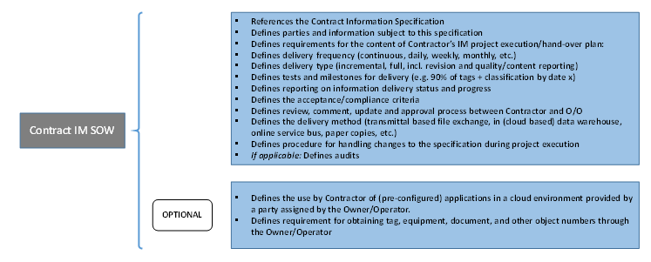
Figure A-2: Contract IM Scope of Work content based on CFIHOS
图A-2 基于CFIHOS的合同IM工作范围内容
Figure A-3: Contract Information Specification content
图A-3 合同信息规范内容

